**Data Challenge’24 Report**

**Dataset:**

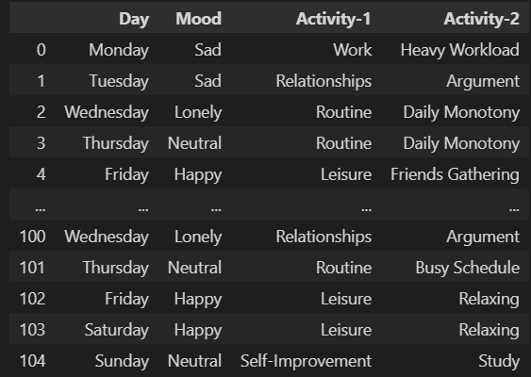

Our dataset has 105 rows $×$ 4 columns

**Graph Plot between Day vs Mood**

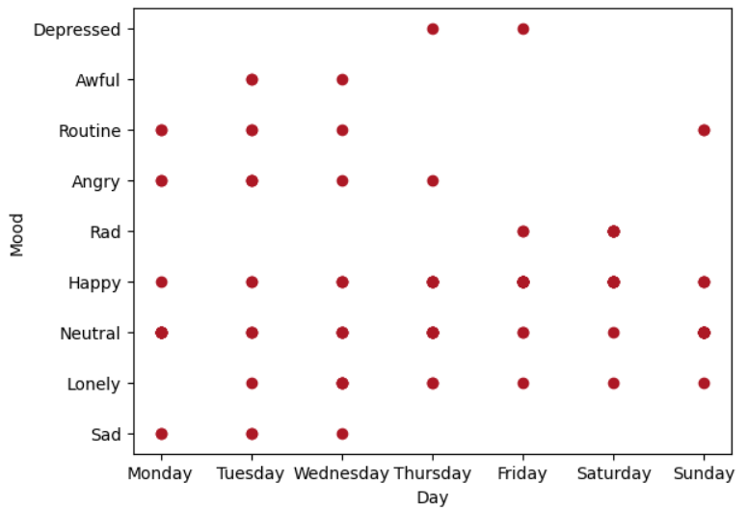

**Graph Plot between Mood vs Activity-1**

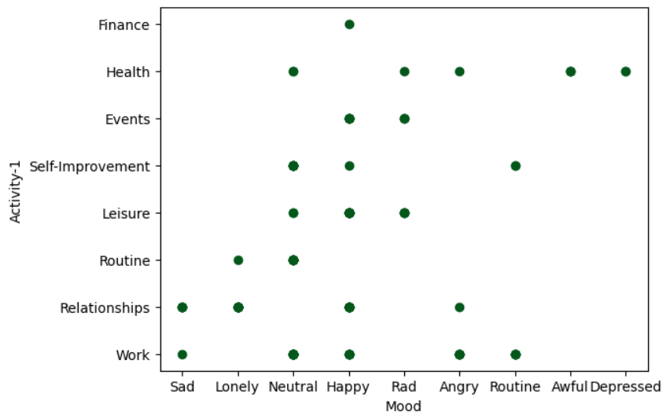

**Graph Plot between Day vs Activity-1**

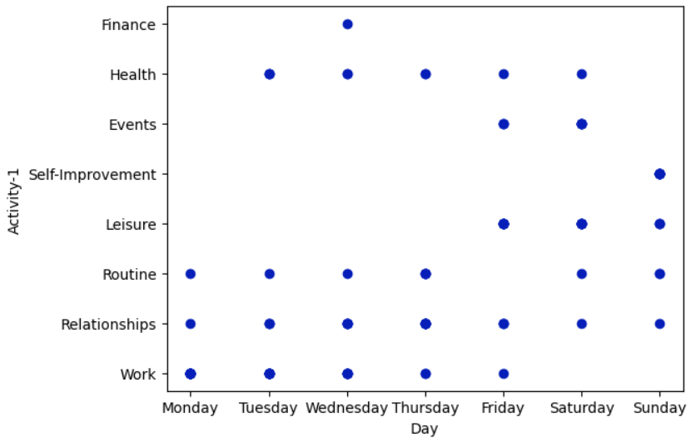

**Graph Plot between Day vs Activity-2**

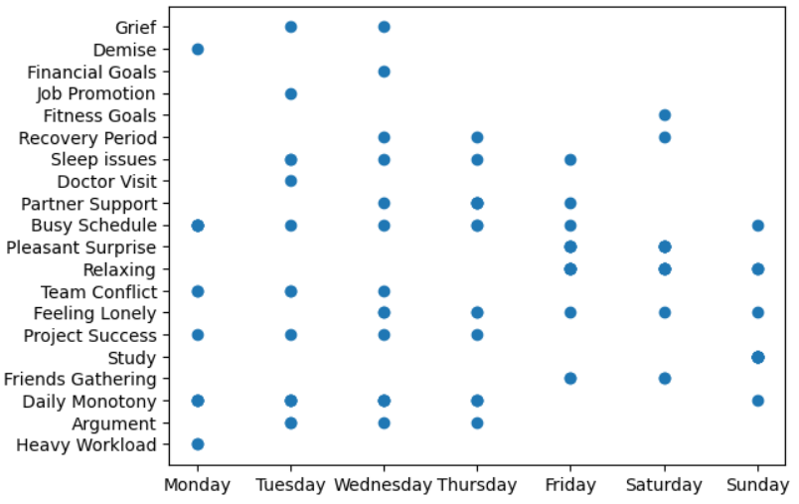

To train the data, I first use label hot encoding to convert the string data values to numeric values.

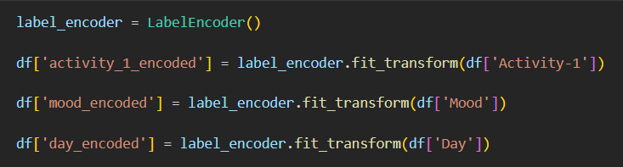

Next, I use the split train test. Here, I'm estimating an activity that depends on the day's and the mood's variables, respectively.

I use Sklearn library for train test split for splitting data

Training data = 0.8

Testing data = 0.2

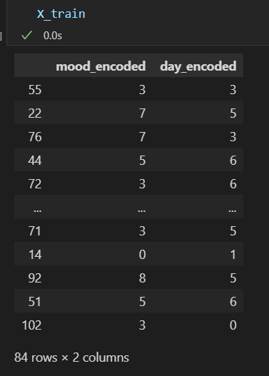 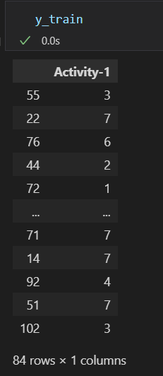

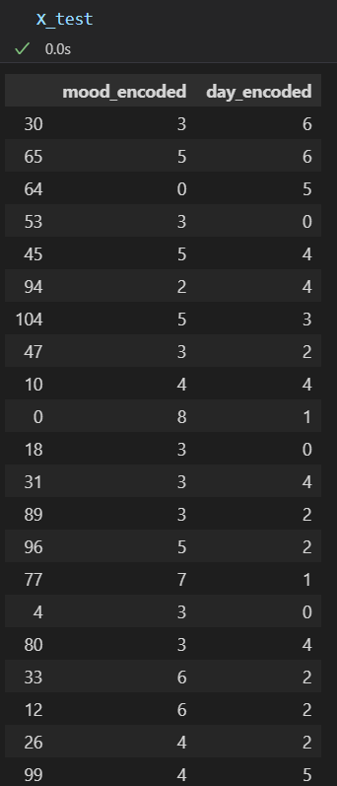 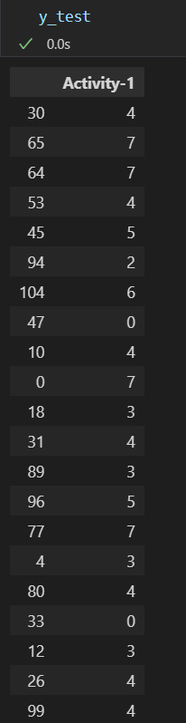

Then I use the Decision Tree Algorithm with a max-depth of 4 to estimate the activity

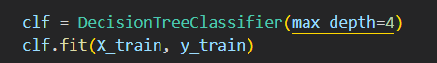

I pass the training data to an algorithm and then build the Decision Tree

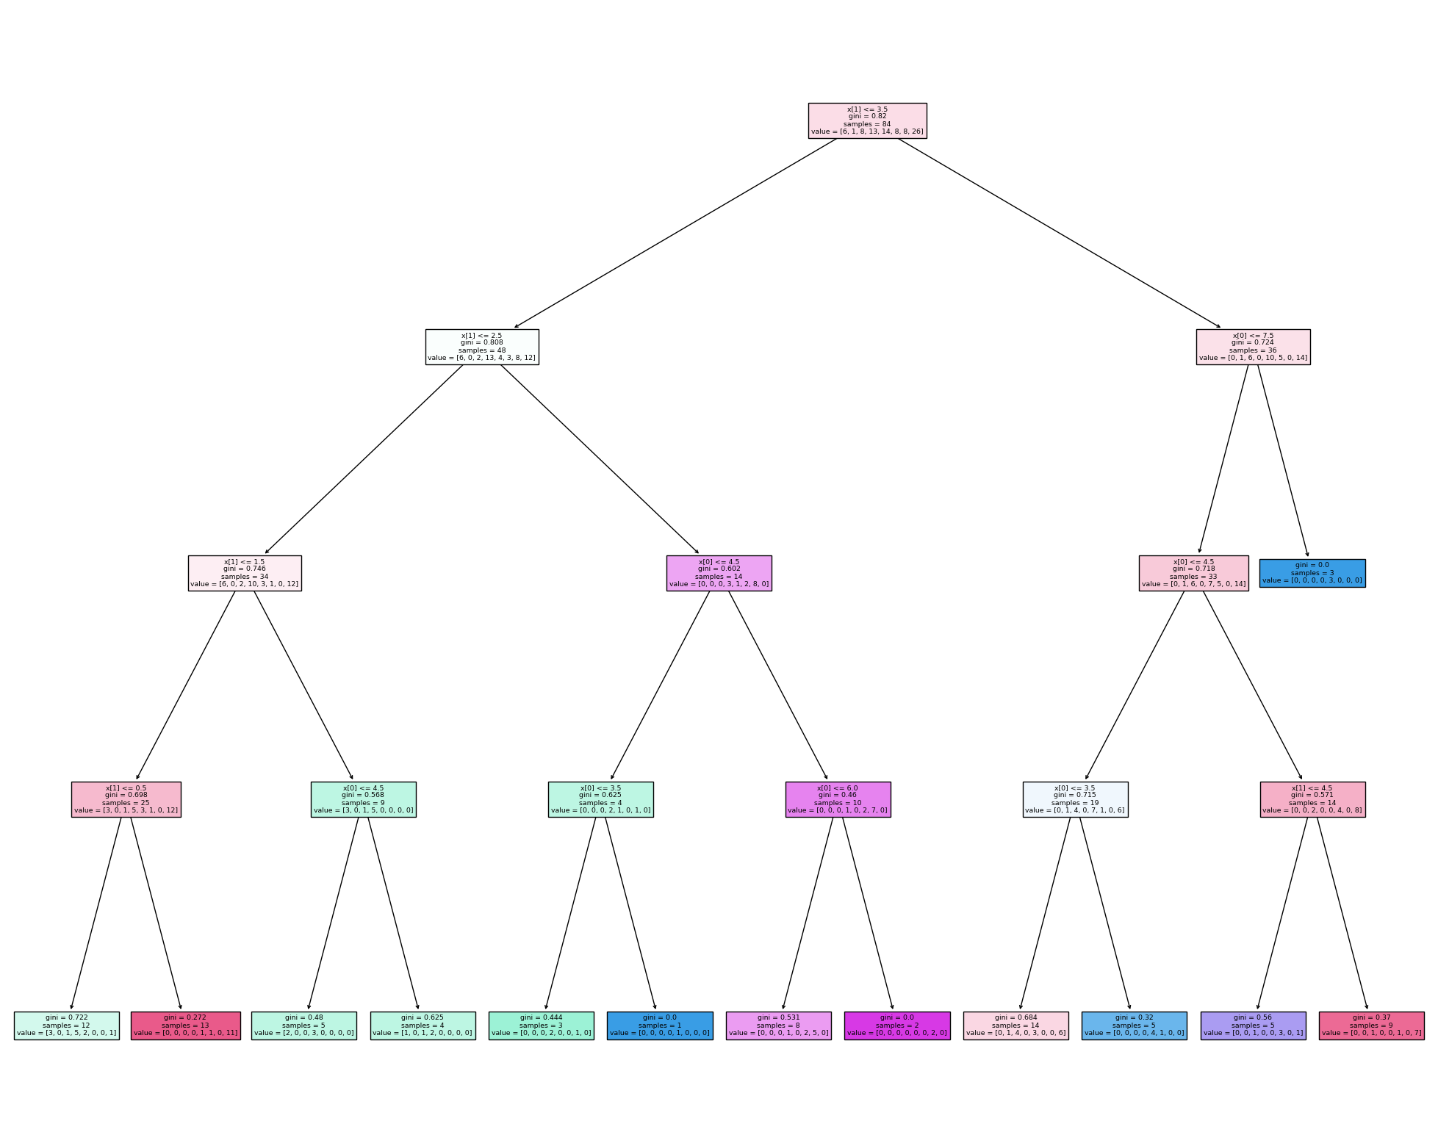

Then after training, I check for validation using the test dataset

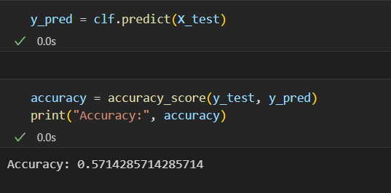

This is the resultant Accuracy of my model

